UNIVERSITY OF MINNESOTA

***Duluth Campus*** ***Department of Sociology -Anthropology*** 228 *Cina Hall*

*1123 University Drive*

*College of Liberal Arts Duluth, Minnesota 55812-3306*

*Office:218-726-7551*

*Fax: 218-726-7759*

[*http://www.d.umn.edu/socanth*](http://www.d.umn.edu/socanth)

*9 October 2016*

Understanding Global Cultures Week 7

**Midterm Exam**

**Malaysia**

[Culture-Bound Syndromes](http://www.d.umn.edu/cla/faculty/troufs/anth4616/cpculture-bound_syndromes.html#title)

"Normal" / "Abnormal"

**[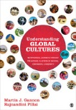](http://www.d.umn.edu/cla/faculty/troufs/anth1095/fstext.html#title)**

**The first business of the week, on Tuesday,**

**is the Midterm Exam.**

**The Midterm Exam is Tuesday, 11 October 2016**. **Live Chat, for last-minute questions, is Monday at 7:00 p.m.** **Other** **Information on the Midterm Exam** is available at <<http://www.d.umn.edu/cla/faculty/troufs/anth1095/exams_midterm.html#title>>.

 [**Live Chat -- Review for Midterm Exam, Monday, 10 October 2016, from 7:00 - 8:00 CDT**](https://ay16.moodle.umn.edu/mod/chat/view.php?id=6373)

**Don’t forget . . .** that you can use the information in the class **Midterm wiki as study questions for the Midterm**.Your questions are annotated; be sure to read my comments and suggestions about the questions. I will have added a couple of questions. The Midterm will be **four essay questions**, selected from a pool generated from those included in the wiki:

 [**Wiki: Contribute your question to the Midterm Exam**](https://ay16.moodle.umn.edu/mod/wiki/view.php?id=6295)

**The final pool of questions generally contains 12-16 questions, all taken from the annotated wiki list of questions, including at least one current affairs question that I will add.** [The final pool of questions will not include more than one question on the same (or essentially similar question), which is why it usually ends up with 12-16 questions).]



 [**MIDTERM EXAM** -- Timed at 75 minutes. Tuesday, 11 October 2016 (the timing will start after you read the introduction, when you say 'go'")](https://ay16.moodle.umn.edu/mod/quiz/view.php?id=6375)

After the Midterm Exam—and for much of **the remainder of the term**—we’ll be spending most of the time, up until we begin your **class presentations**, examining **cultures around the world**.

**On Thursday, before we continue having a look Italy**—and our focus on deconstructing the making of a cultural metaphor—**we’ll have a look at Malaysia, and a *very* interesting “culture-bound psychological syndrome” known as *Latah*—a startle reflex reaction.**

**Thursday news feature of the week also features Malaysia . . .**

~

|  |  |  |  |  |  |
| --- | --- | --- | --- | --- | --- |
| Week 7 Day 14, Thursday, 15 October 2015      [**Malaysia**](http://www.d.umn.edu/cla/faculty/troufs/anth1095/Malaysia.html#title) **> Paulin L.**   |  | | --- | |  | | [News Media](http://www.d.umn.edu/cla/faculty/troufs/anth1095/Malaysia.html#news) | [Country Profiles](http://www.d.umn.edu/cla/faculty/troufs/anth1095/Malaysia.html#profiles) | | [The CIA World Factbook](https://www.cia.gov/library/publications/the-world-factbook/) > [Malaysia](https://www.cia.gov/library/publications/the-world-factbook/geos/my.html) | | [BBC News](http://www.bbc.co.uk/) > Malaysia Profile | Malaysia Timeline | |  | |

~

If have not yet heard about your “[**Promissory Abstract**](http://www.d.umn.edu/cla/faculty/troufs/comp3160/Hairston.abstracts.html#promissory)”, and **Working Bibliography**, you will be hearing about it shortly.

Be sure to check the details of the **activities and assignments** of the week in your **Moodle** folder . . .

[**After the Exam Take the Two (Very Short) Selective Attention Tests in Preparation for Watching Remaining Videos**](https://ay16.moodle.umn.edu/mod/page/view.php?id=6393)

 [**Response to the film *Latah: A Culture Specific Elaboration of the Startle Reflex*** (Due by the end of Week 7—Saturday, 15 October 2016; Your Name Will Be Logged) Feedback](https://ay16.moodle.umn.edu/mod/feedback/view.php?id=6395)

** Go back and look over your**[**Midterm Exam**](http://www.d.umn.edu/cla/faculty/troufs/anth1095/exams_midterm.html#title)**, including your answers**.

**Review . . .**

[OWL logo--Online Writing Lab, Purdue University](http://owl.english.purdue.edu/owl/)

[**Writing Essays for Exams**](http://owl.english.purdue.edu/owl/resource/737/1)

[**Test Taking Strategies**](http://www.d.umn.edu/student/loon/acad/strat/test_take.html)

REM: Share your ideas at . . .

f2016 **Student Collaboration Space**

for your own personal use

 [**Wiki for Project Collaboration**](https://ay16.moodle.umn.edu/mod/wiki/view.php?id=6151)

QUICKMAIL (see sidebar)

The above items will be found at the top of your **Moodle** folder under “Student Collaboration Space”.

Check the results of the class Video Responses from earlier weeks when they close. You can find the results in the **Moodle** Blocks where they first appeared. This week have a look at . . .

Summarizing, they are . . .

 [Results--*After Winter, Spring* f2016 File resource](https://ay16.moodle.umn.edu/mod/resource/view.php?id=6328)

 [Results--*Strange Relations* f2016 File resource](https://ay16.moodle.umn.edu/mod/resource/view.php?id=663697)

**For Fun:**

This week’s trivia question:

**How many languages are spoken in** [*the city of* London](http://www.christiantate.co.uk/?p=344)**?**

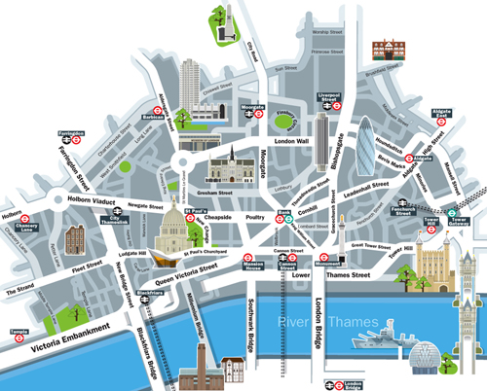

[Answer](http://www.d.umn.edu/cla/faculty/troufs/anth1095/trivia/gctrivia_London_languages.html#answer)

Your **Readings** and **Activities listings** are available in the **Week 7 Block** of your **Moodle** folder.

If you have any **questions** right now, please do not hesitate to post them on the **Moodle** “QUICKMAIL”, "Messenger" or e-mail [troufs@d.umn.edu](mailto:troufs@d.umn.edu) , or stop in before class across the hall in Cina 215.

Best Regards,

Tim Roufs

<[http://www.d.umn.edu/~troufs/](http://www.d.umn.edu/%7Etroufs/)>